**THANTHI PERIYAR GOVERNMENT ART’S & SICENCE (A) COLLEGE (Department of Mathematics)**

**Team number :6**

**NM ID**  **:NM2023TMID02952**

**Team Leader : MUTHURAM M**

**Team Members : 5**

**Team Members Name : Karthi, Logesh, Muruganatham, Navaneethapandiyan**

**Title: A Quantitative Analysis of Candidates in the 2019 Lok sabha Elections.**

1. **Introduction:**

**1.1 Overview:** "Political Juggernauts: A Quantitative Analysis of Candidates in the Lok Sabha Elections" is a comprehensive research study that employs quantitative methods to delve into the intricate dynamics of India's Lok Sabha elections. This analysis scrutinizes a wide range of factors, including candidate profiles, party strategies, electoral outcomes, and voter behavior, offering valuable insights into the workings of this crucial democratic process. The study contributes to a deeper understanding of candidate selection, party politics, and electoral trends in the Indian context, serving as a valuable resource for policymakers, political strategists, and anyone interested in the nuances of the Lok Sabha elections.

**1.2 Purpose:** "Political Juggernauts: A Quantitative Analysis of Candidates in the  
Lok Sabha Elections" is to provide a data-driven exploration of the factors influencing India's Lok Sabha elections. Through quantitative analysis, this study seeks to uncover insights into candidate attributes, party dynamics, voter behavior, and election trends. By doing so, it offers a deeper understanding of the complexities surrounding candidate selection and electoral outcomes, making it a valuable resource for political scholars, policymakers, and those interested in the mechanics of India's democratic processes.

1. **Problem Definition & Design Thinking:**
   1. **Empathy Map:**

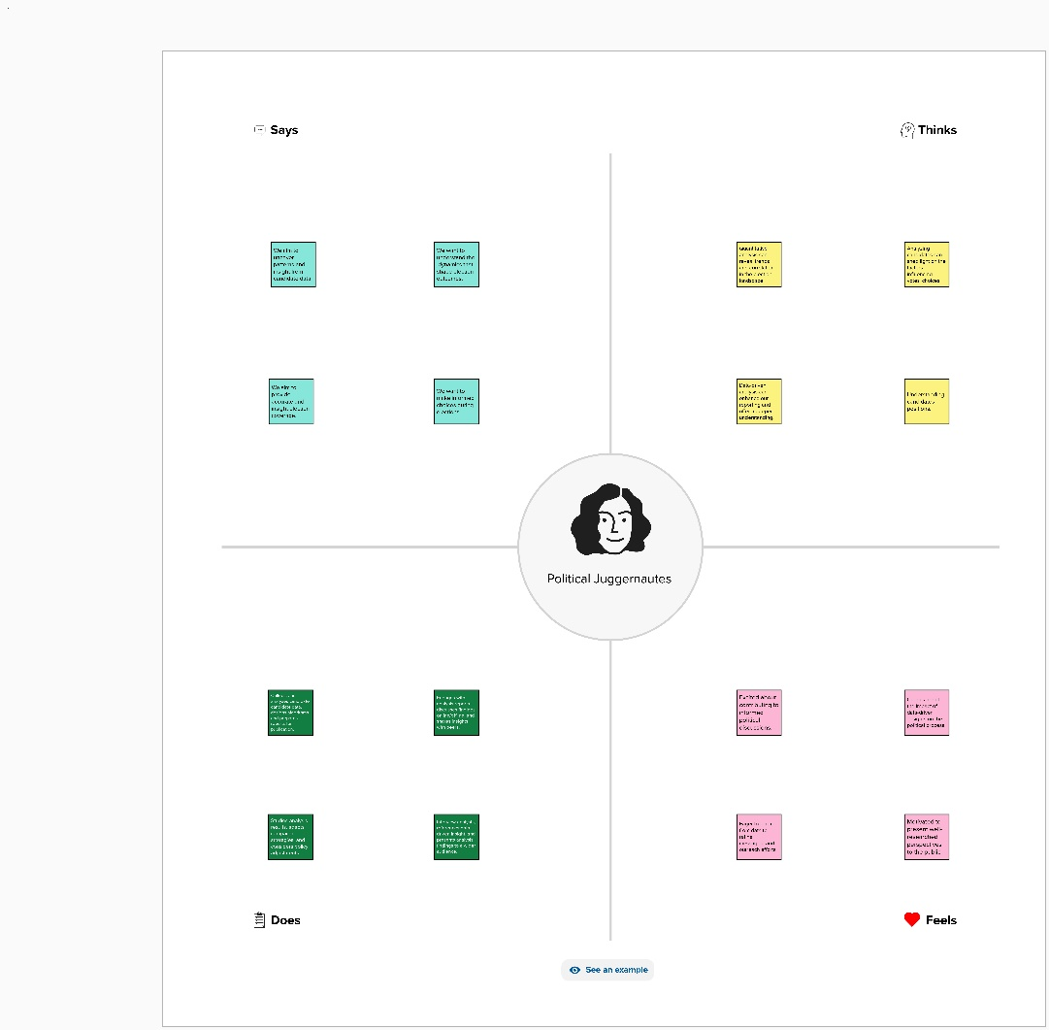

* 1. **Ideation & Brain storming Map:**

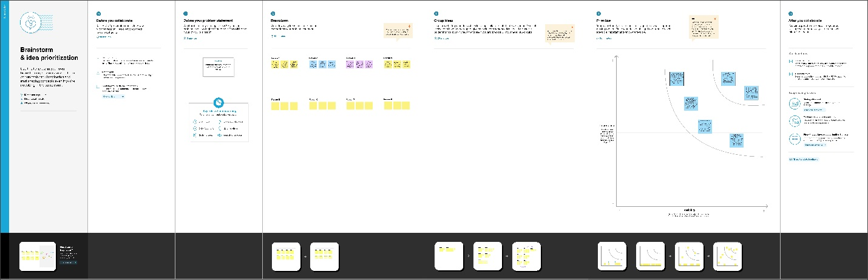

**Sheets:**

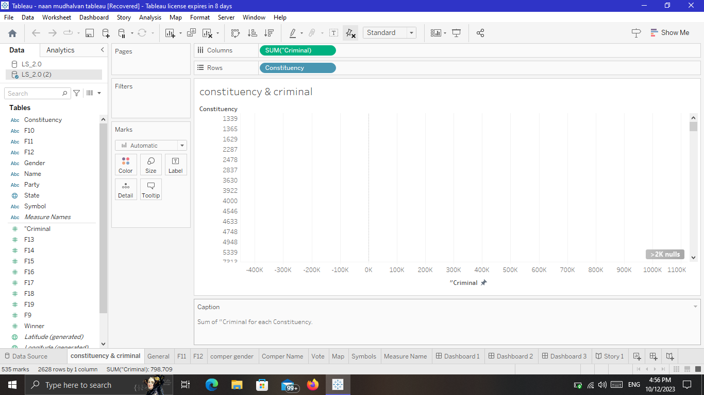

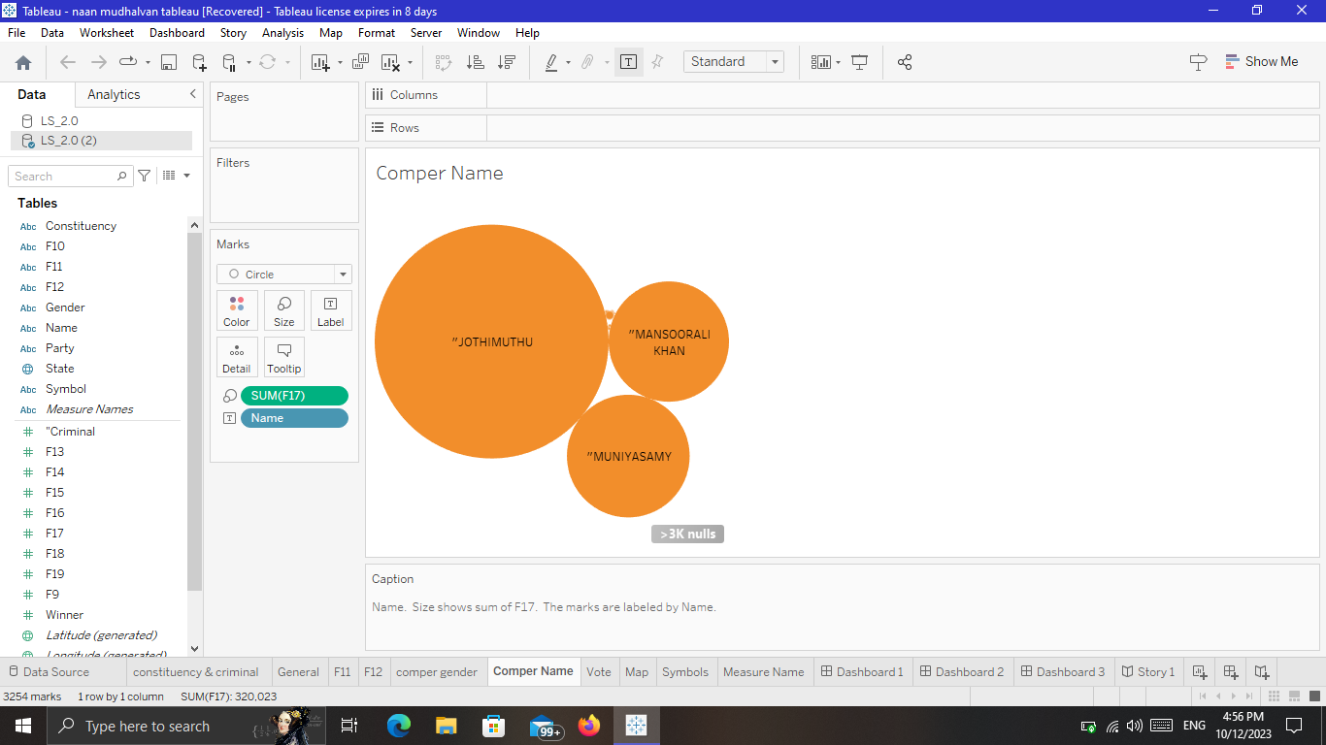

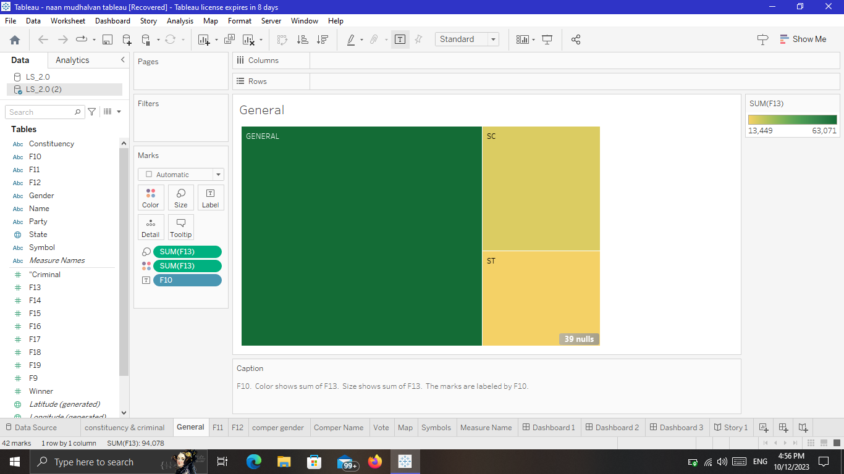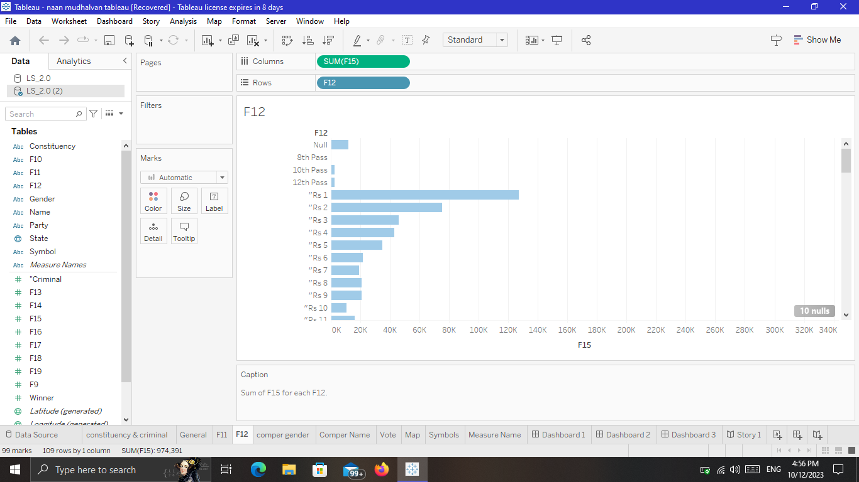

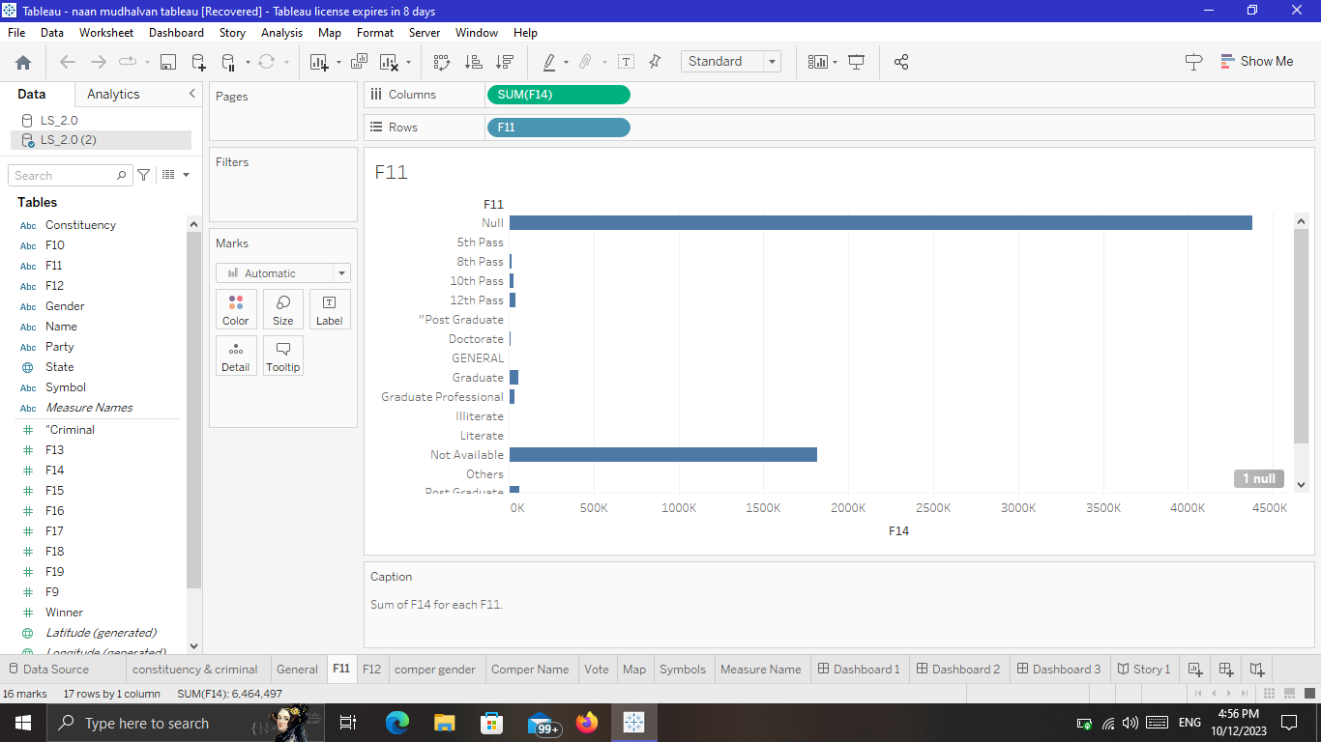

**Dashboard:**

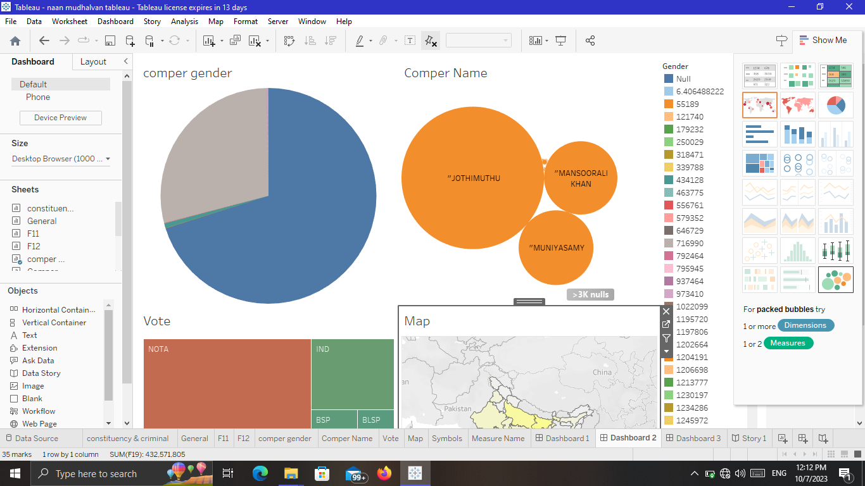

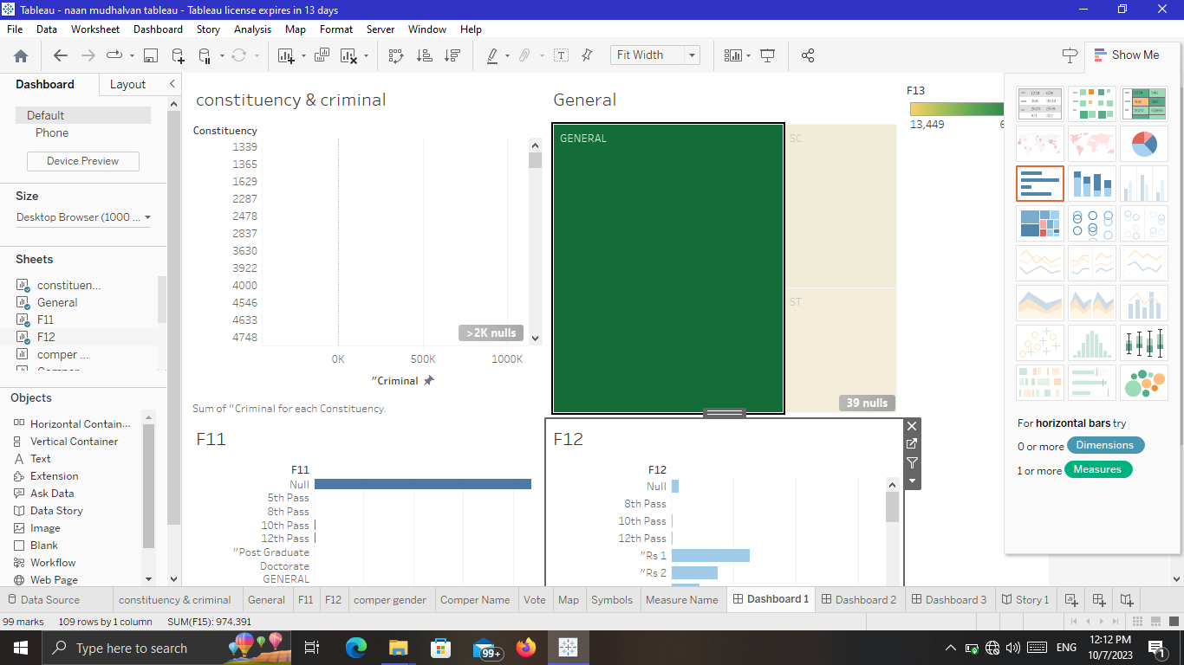

**Story:**

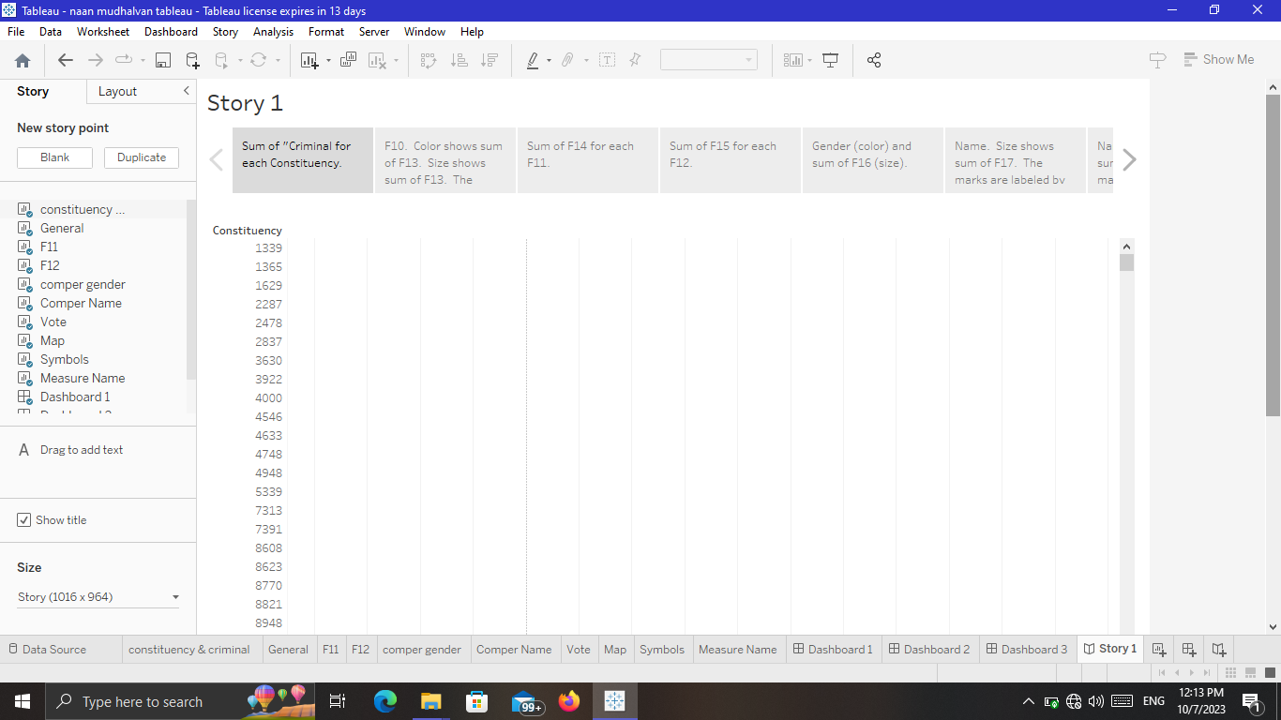

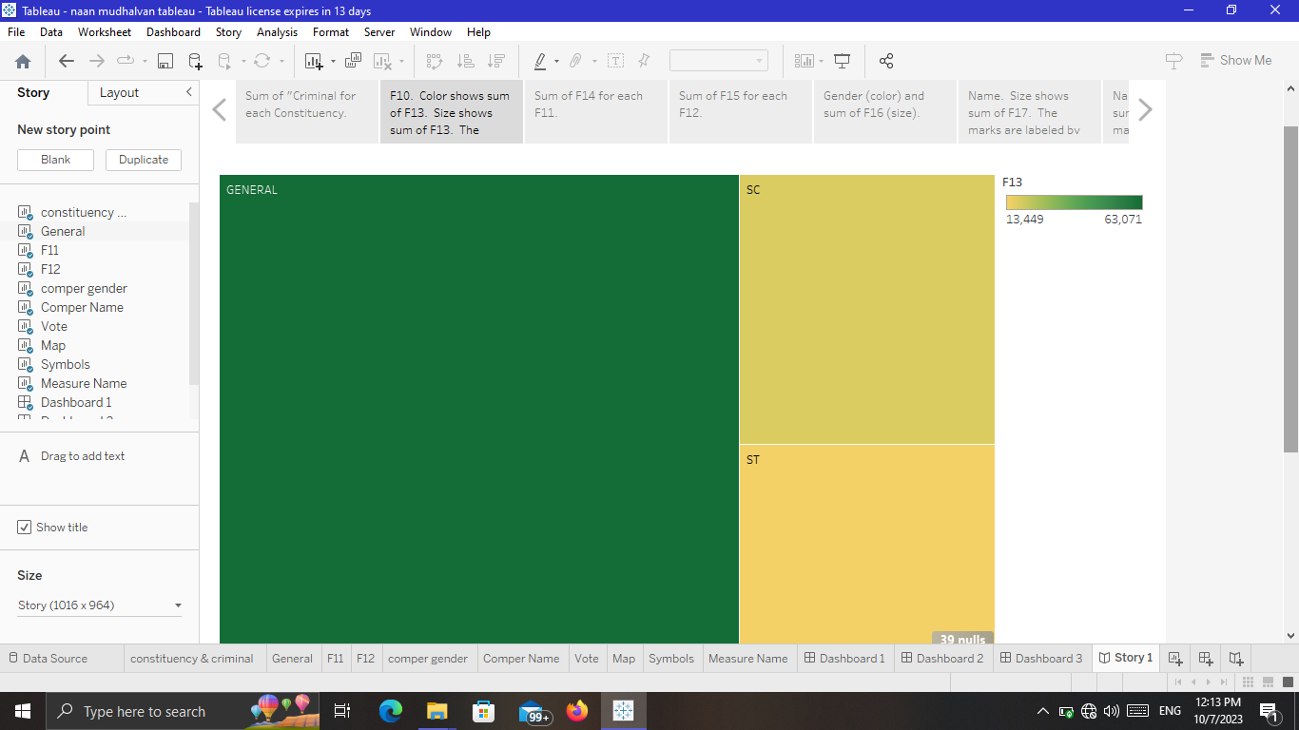

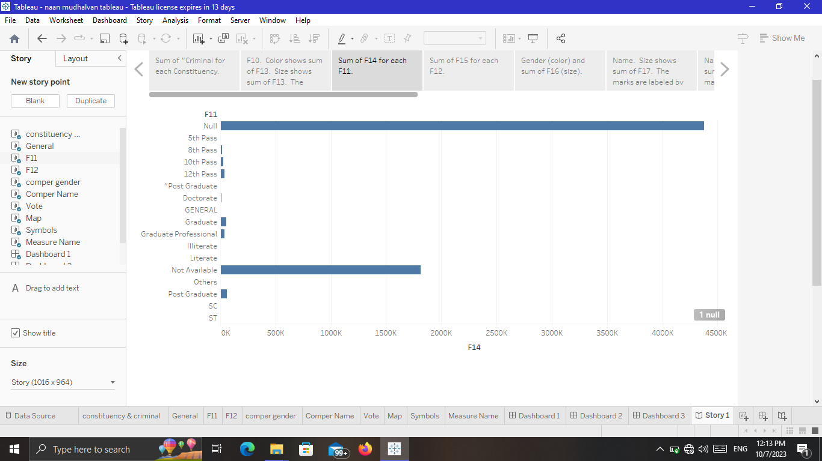

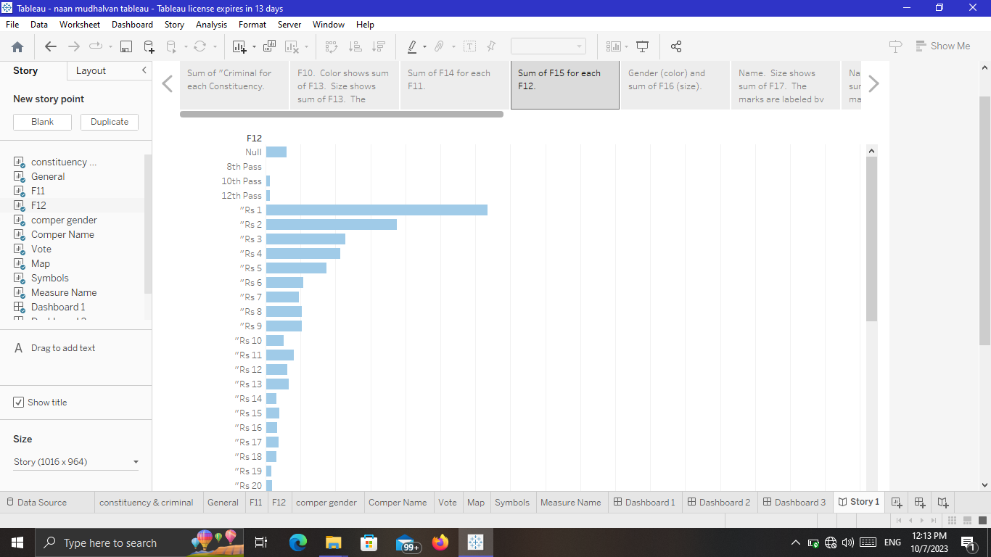

**Advantages and Disadvantages**

The 2019 general election that reelected the incumbent party shows significant irregularities in election data.

**Applications**

The ruling party’s victory has been broad-based, gaining seats in most parts of the country, and across the rural-urban divide, cementing its pole position in Indian politics.

**Conclusion**

On average, 14.8 candidates are contesting per constituency across the country. Among all the states, Telangana has the highest average number of candidates contesting. Overall, the BJP’s appeal seems to transcend the divides of caste, education, and affluence, data suggests. But there are some differences—with the BJP less successful in more educated constituencies.

**Future Scope:**

Though the size of the alleged manipulation is small, the results signify a worrying   
development for the future of democracy in India and consequently, in the world at large.